# Software Requirement and Design Specifications

## Hostel Management System

***Version (1)***

|  |  |
| --- | --- |
| *Course Code* | CS-3004 |
| *Instructor* | Miss Nida Munawar |
| *Project Team* | Fabiha Atique 20k-0369 Muhammad Usama 20k-0190 |
| *Submission Date* | 7/December/2022 |

## [Instructions]

* *No section of template should be deleted. You can write ‘Not applicable’ if a section is not applicable to your project. But all sections must exist in the final document.*
* *All comments/examples mentioned in square brackets ([]) are in the template for explanation purposes and must be replaced / removed in final document.*
* *This’ Instruction’ section should also be removed from the final document.*

*Table of Contents*

1. INTRODUCTION 5
   1. Purpose of Document 5
   2. Intended Audience 5
2. OVERALL SYSTEM DESCRIPTION 6
   1. Project Background 6
   2. Project Scope 6
   3. Not In Scope 6
   4. Project Objectives 6
   5. Stakeholders 6
   6. Operating Environment 6
   7. System Constraints 6
   8. Assumptions & Dependencies 6
3. EXTERNAL INTERFACE REQUIREMENTS 7
   1. Hardware Interfaces 7
   2. Software Interfaces 7
   3. Communications Interfaces 7
4. FUNCTIONAL REQUIREMENTS 8
   1. FUNCTIONAL HIERARCHY 8
   2. Use Cases 8
      1. [Title of use case] 8
5. NON-FUNCTIONAL REQUIREMENTS 9
   1. Performance Requirements 9
   2. Safety Requirements 9
   3. Security Requirements 9
   4. User Documentation 9

SDS 10

1. SYSTEM ARCHITECTURE 11
   1. SYSTEM LEVEL ARCHITECTURE 11
   2. SOFTWARE ARCHITECTURE 11
2. DESIGN STRATEGY 12
3. DETAILED SYSTEM DESIGN 13
   1. DATABASE DESIGN 13
4. APPLICATION DESIGN 15
5. REFERENCES 15
6. APPENDICES 17

## Introduction

##### Purpose of Document

The purpose of this document is to present our academic project is an effective way and give a tour to our audience about how a hostel management system words.

##### Intended Audience

Course instructor, Instructor’s Assistant, students enrolled in the course.

* 1. **Definition of Terms, Acronyms and Abbreviations**

Not applicable

|  |  |
| --- | --- |
| ***Term*** | ***Description*** |
| *ASP* | *Active Server Pages* |
| *DD* | *Design Specification* |
|  |  |
|  |  |
|  |  |
|  |  |
|  |  |
|  |  |

##### Document Convention

Font size is 10 for the normal paragraphs and 12 for headings. Font: Areal

## Overall System Description

##### Project Background

Many fellow students at our university are living in hostels, it is important to know about the management system of the institutions we belong to. Hence, we have presented a model to demonstrate how a normal hostel works.

##### Project Scope

This system can be used by students to enhance their knowledge about how management systems work in practical life, . Also, it can be used by the actual hostel owners to design and perform their management using our system.

##### Not In Scope

Chat box for students’ assistance, salary management of warden and rent management of the whole hostel building.

##### Project Objectives

To Give an idea to about of how management is done, how many functionalities are involved in seemingly simple tasks.

##### Stakeholders

Users (students and warden) admin and database developer.

##### Operating Environment

Web browsers on laptops and computers.

##### System Constraints

The following are the few constraints due to which it gets harder for the team to provide the best of the services.

* + - *Web server limitations.*
    - *Internet not working*
    - *Many students who do not live in hostels or are not in favor of living in hostels.*
    - *The Authorities are not in favor of the hostels to be managed privately.*
    - *The environment where our system is deployed do not have skilled people, for example people do not know how to manage the database etc.*
    - *User constraints, the students and the wardens are non-serious and do not cooperate with the system.*

##### Assumptions & Dependencies

* + - *We are dependent on our database system, due to which we can store and retrieve so much data.*
    - *We are dependent on the internet for this system to work.*

## External Interface Requirement

external requirements are shown in the deployment diagrams below.

## 3.1 Hardware interfaces

We will be needing a computer to manage and view the database.

##### Software Interfaces

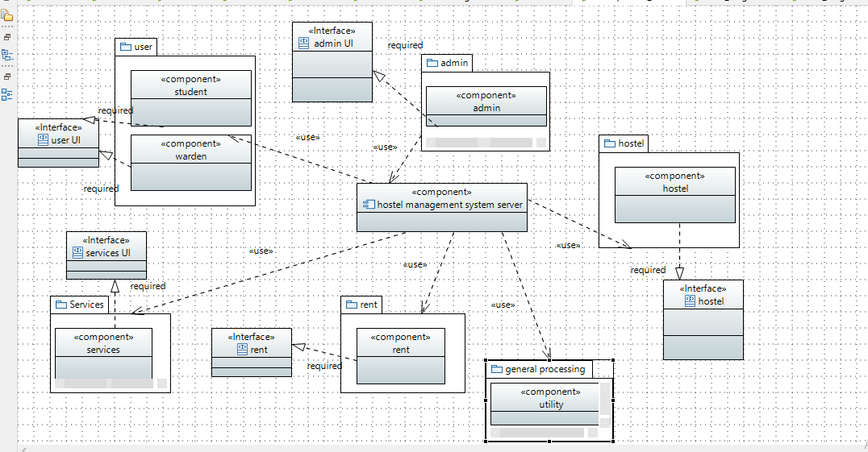The following component diagram describes the components of the classes, their connections, their dependencies and uses.

##### Communications Interfaces

[non applied as of now]

## Functional Requirements

##### Functional Hierarchy

The functionalities are either by the student or the warden. For warden

* + - *Registration*
    - *Log in*
    - *Add student*
    - *Add facility in hostel*
    - *Delete facility in hostel*
    - *Check student rent status*
    - *Generate rent voucher*
    - *Validate student payments* *For student*
    - *Registration*
    - *Log in*
    - *Avail facility*
    - *Discontinue facility*
    - *Complain regarding a facility*
    - *Check rent voucher*
    - *Pay rent*

##### Use Cases

* + 1. 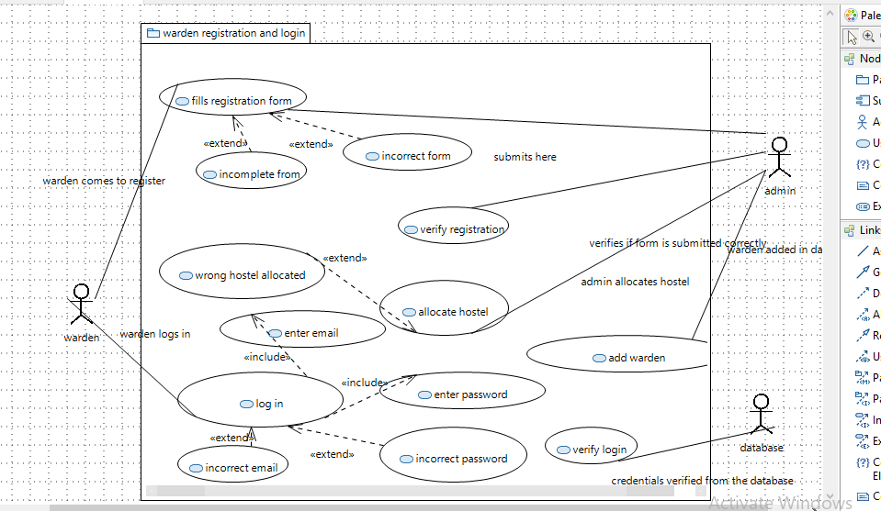***Warden registration and login***

|  |  |
| --- | --- |
| Id | UC1 |
| USE CASE NAME | Warden registration form |
| AUTHOR | FABIHA ATIQUE, MOHAMMAD USAMA |
| LAST REVISED | 26/11/2022 |
| DESCRIPTION | The system will add the warden in the system |
| PRIMARY ACTOR | Warden |
| SUPPORTING ACTOR | Student, database |
| PRECONDITION | The user is connected to the internet. |
| POSTCONDITION | The Warden has successfully registered. |
| MAIN SUCCESS SCENERIOS | 1. The warden fills a form in which he enters his information. 2. The warden submits his form. |
| EXTENSIONS | *a. At any time, the system crashes. |

|  |  |
| --- | --- |
|  | 1a. The warden does not fill a necessary column.  2a. The warden forgets to submit the form. |

|  |  |
| --- | --- |
| Id | UC2 |
| USE CASE NAME | Verify registration form |
| AUTHOR | FABIHA ATIQUE, MOHAMMAD USAMA |
| LAST REVISED | 26/11/2022 |
| DESCRIPTION | The admin checks if the form is  submitted correctly |
| PRIMARY ACTOR | Admin |
| SUPPORTING ACTOR | Warden, student |
| PRECONDITION | The admin staff is connected to the system  The warden has filled the registration form |
| POSTCONDITION | The form is approved and the warden is added |
| MAIN SUCCESS SCENERIOS | 1. The system checks all the details which are provided in the form. 2. The system approves the form. 3. The system allocates a hostel to the warden. 4. The system enters the warden details in the   database. |
| EXTENSIONS | *a. At any time, the system crashes.  1a. The system is unable to detect an invalid form.  2a. the system is unable to approve the correct form.  3a. the system does not provide hostel to the warden.  3b. The system gives a hostel to the warden which already has a warden.  4a. the system enters incomplete information in the database.  4b. the system enters incorrect information in the database. |

|  |  |
| --- | --- |
| Id | UC3 |
| USE CASE NAME | Warden log in |

|  |  |
| --- | --- |
| AUTHOR | FABIHA ATIQUE, MOHAMMAD USAMA |
| LAST REVISED | 26/11/2022 |
| DESCRIPTION | The warden logs in the system |
| PRIMARY ACTOR | Warden |
| SUPPORTING ACTOR | Database, student |
| PRECONDITION | The user is connected to the internet.  The user has already registered in the system as a warden. |
| POSTCONDITION | The warden successfully logs in. |
| MAIN SUCCESS SCENERIOS | 1. The warden clicks on the sign in button. 2. The warden enters his credentials 3. The warden clicks on the submit button. |
| EXTENSIONS | *a. At any time, the system crashes.  2a the warden enters invalid credentials.  3a. The warden forgets to click on the submit button. |

|  |  |
| --- | --- |
| Id | UC4 |
| USE CASE NAME | Verify warden login |
| AUTHOR | FABIHA ATIQUE, MOHAMMAD USAMA |
| LAST REVISED | 26/11/2022 |
| DESCRIPTION | The warden’s credentials are verified from the database. |
| PRIMARY ACTOR | Database |
| SUPPORTING ACTOR | Admin, student, warden |
| PRECONDITION | The user is connected to the internet.  The warden is registered in the system.  The warden attempts to login to  the system. |
| POSTCONDITION | The student is successfully logged In and can see the current status and facilities provided by  the system. |
| MAIN SUCCESS SCENERIOS | 1. The warden’s id is verified. 2. The warden’s password is verified. 3. Logged in successfully. |
| EXTENSIONS | *a. At any time, the system  crashes. |

|  |  |
| --- | --- |
|  | 1a. The warden enters invalid email.  2a. the warden enters an invalid password.  3a. even after correct credentials, the warden is not logged in. |

* + 1. 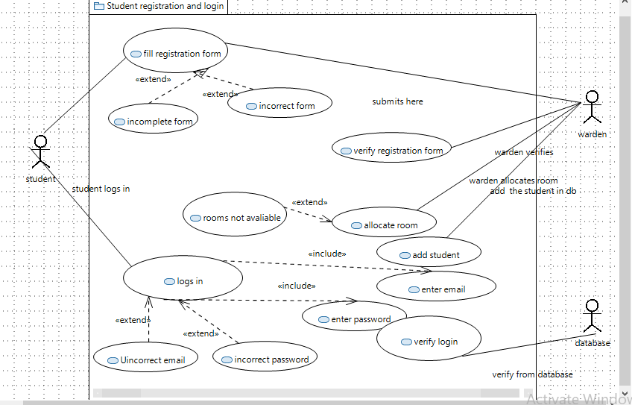***Student registration and login***

|  |  |
| --- | --- |
| Id | UC5 |
| USE CASE NAME | Student fills registration form |
| AUTHOR | FABIHA ATIQUE, MOHAMMAD USAMA |
| LAST REVISED | 26/11/2022 |
| DESCRIPTION | The student comes and registers  himself in the system so he can live in the hostel. |
| PRIMARY ACTOR | Student |
| SUPPORTING ACTOR | Admin, Warden |
| PRECONDITION | The user is connected to the internet. |

|  |  |
| --- | --- |
| POSTCONDITION | The user successfully fills the registration form |
| MAIN SUCCESS SCENERIOS | 1. The student clicks on the registration button. 2. The student enters his information in the form for registration. 3. The student clicks the submit button. |
| EXTENSIONS | *a. At any time, the system crashes.  2a. The student by mistake does not enter some information, incomplete form gives an error. 2b. The student enters some  wrong information. |

|  |  |
| --- | --- |
| Id | UC6 |
| USE CASE NAME | Verify student registration |
| AUTHOR | FABIHA ATIQUE,MOHAMMAD USAMA |
| LAST REVISED | 26/11/2022 |
| DESCRIPTION | The warden checks if the student has filled the registration form correctly. |
| PRIMARY ACTOR | Warden |
| SUPPORTING ACTOR | Admin, student |
| PRECONDITION | The user is connected to the internet.  The student has filled the form. |
| POSTCONDITION | The registration has been verified. |
| MAIN SUCCESS SCENERIOS | 1. The warden checks the details entered in the form. 2. The warden approves the registration. 3. The warden allocates a room to the student. 4. The warden adds the student information in the database. |
| EXTENSIONS | *a. At any time, the system crashes.  1a. The admin fails to check the registration form correctly.  2a. The form is checked and is ok but the warden forgets to approve the registration.  3a. The warden forgets to allocate the room to the student. |

|  |  |
| --- | --- |
|  | 3b. The warden allocates room which is already taken.  4a. The warden forgets to add the student in the database.  4b. the warden adds incorrect information in the database. |

|  |  |
| --- | --- |
| Id | UC7 |
| USE CASE NAME | Student Log in |
| AUTHOR | FABIHA ATIQUE, MOHAMMAD USAMA |
| LAST REVISED | 26/11/2022 |
| DESCRIPTION | The student logs in to the system to check the facilities provided by  the hostel and check status. |
| PRIMARY ACTOR | Student |
| SUPPORTING ACTOR | Admin, warden |
| PRECONDITION | The user is connected to the internet.  The student is registered in the system. |
| POSTCONDITION | The student is successfully logged In and can see the status  and facilities provided by the system. |
| MAIN SUCCESS SCENERIOS | 1. The student enters the ID and password to login. 2. The student clicks on the login button. |
| EXTENSIONS | *a. At any time, the system crashes.  1a. The student enters invalid log in credentials.  1b. the credentials are valid, but  the student is unable to log in. |

|  |  |
| --- | --- |
| Id | UC8 |
| USE CASE NAME | Verify log in |
| AUTHOR | FABIHA ATIQUE, MOHAMMAD USAMA |
| LAST REVISED | 26/11/2022 |
| DESCRIPTION | The login credentials are verified  from the database. |
| PRIMARY ACTOR | Database |
| SUPPORTING ACTOR | Admin, warden, student |
| PRECONDITION | The user is connected to the  internet. |

|  |  |
| --- | --- |
|  | The student is registered in the system.  The user has attempted to login. |
| POSTCONDITION | The student is successfully logged In and can see the status  and facilities provided by the system. |
| MAIN SUCCESS SCENERIOS | 1. The email is verified from the database. 2. The password is verified from the database. 3. If both matches, then the user is allowed to login. |
| EXTENSIONS | *a. At any time, the system crashes.  1a. the email was incorrect. 2a. the password was invalid. |

#### Manage hostel facilities

|  |  |
| --- | --- |
| Id | UC9 |
| USE CASE NAME | Display facilities |
| AUTHOR | FABIHA ATIQUE, MOHAMMAD USAMA |
| LAST REVISED | 26/11/2022 |

|  |  |
| --- | --- |
| DESCRIPTION | The system displays the facilities  a warden can provide in his hostel. |
| PRIMARY ACTOR | Database |
| SUPPORTING ACTOR | Student, Admin, warden |
| PRECONDITION | The system is connected to the internet |
| POSTCONDITION | The facilities will be displayed. |
| MAIN SUCCESS SCENERIOS | 1. The facilities button will be present on the front end. 2. The facilities will be displayed on the screen. |
| EXTENSIONS | *a. At any time, the system crashes.  2a. No facilities are displayed on screen.  2b. incomplete facilities list is displayed on screen. |

|  |  |
| --- | --- |
| Id | UC10 |
| USE CASE NAME | Add facilities |
| AUTHOR | FABIHA ATIQUE, MOHAMMAD USAMA |
| LAST REVISED | 26/11/2022 |
| DESCRIPTION | The warden adds the facilities  that can be provided to the students. |
| PRIMARY ACTOR | Warden |
| SUPPORTING ACTOR | Admin, student, |
| PRECONDITION | The user is connected to the internet. |
| POSTCONDITION | The warden successfully adds the facilities that his branch of hostel will have. |
| MAIN SUCCESS SCENERIOS | 1. The warden will click on the add facilities option. 2. The warden adds the facilities he wants from   the list of available. |
| EXTENSIONS | *a. At any time, the system crashes.  2a. There is not a list of present. 2a. The warden tries to add the  facilities that are not present on the table. |

|  |  |
| --- | --- |
| Id | UC11 |
| USE CASE NAME | Drop facilities |
| AUTHOR | FABIHA ATIQUE, MOHAMMAD USAMA |

|  |  |
| --- | --- |
| LAST REVISED | 26/11/2022 |
| DESCRIPTION | The warden drops the facilities that were originally added. |
| PRIMARY ACTOR | Warden |
| SUPPORTING ACTOR | Student, Admin |
| PRECONDITION | The user has already registered in the system.  The warden has added a few facilities for the hostel. |
| POSTCONDITION | The facilities will be deleted. |
| MAIN SUCCESS SCENERIOS | 1. The warden selects the facilities he wants to delete. 2. The facilities will no longer be available for the   students. |
| EXTENSIONS | *a. At any time, the system crashes.  1a. The warden is trying to delete the facility that was never added.  2a. The facility is deleted but still is showing available. |

|  |  |  |
| --- | --- | --- |
| Id | UC12 |  |
| USE CASE NAME | Facilities updated in the database |
| AUTHOR | FABIHA ATIQUE, MOHAMMAD  USAMA |
| LAST REVISED | 26/11/2022 |
| DESCRIPTION | The facilities added and deleted will be updated in the database. |
| PRIMARY ACTOR | Database |
| SUPPORTING ACTOR | Student, Admin, warden |
| PRECONDITION | The system is connected to the internet.  The warden adds and deletes facilities in their hostel. |
| POSTCONDITION | The data related to facilities will be updated in the database. |
| MAIN SUCCESS SCENERIOS | 1. The facilities that the warden adds are displayed in the database. 2. The facilities deleted will be updated in the   database too. |
| EXTENSIONS | *a. At any time, the system crashes.  1a. the facilities that are added are not shown in the database. 1b. the facilities that are not added are shown in the  database. |

|  |  |
| --- | --- |
|  | 2a. The facilities that are deleted are shown in the database.  2b. the facilities that are not deleted will not be shown in the database/. |

* + 1. 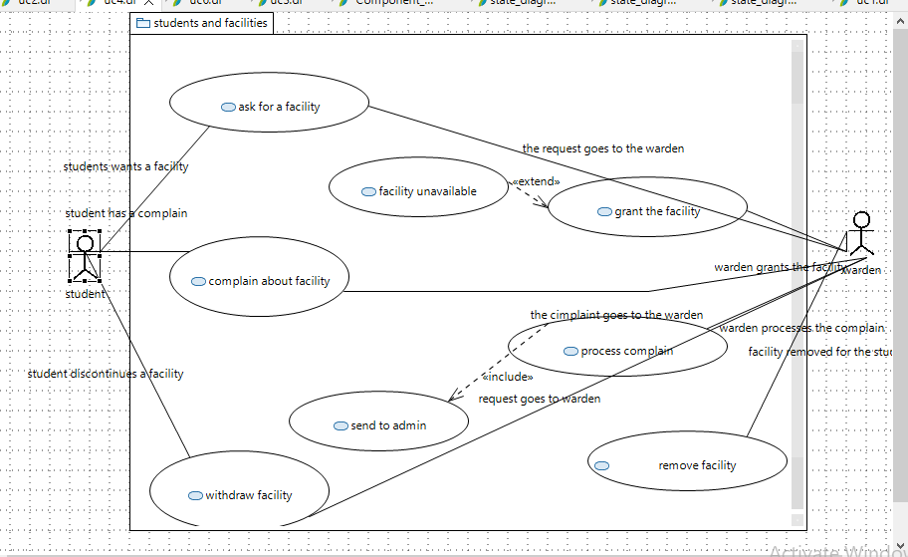***Student and facilities***

|  |  |
| --- | --- |
| Id | UC13 |
| USE CASE NAME | Asks for facility |
| AUTHOR | FABIHA ATIQUE, MOHAMMAD  USAMA |
| LAST REVISED | 26/11/2022 |
| DESCRIPTION | The student asks for a particular facility provided by the hostel |
| PRIMARY ACTOR | Student |
| SUPPORTING ACTOR | Warden, admin, database |
| PRECONDITION | The student has already registered in the system.  The student is logged in. |
| POSTCONDITION | The request is sent to the warden. |
| MAIN SUCCESS SCENERIOS | 1. The student applies for facilities he wants to avail. 2. The warden allows the facilities if available. |

|  |  |  |  |  |
| --- | --- | --- | --- | --- |
| EXTENSIONS | | *a. At any time, the system crashes.  2a. The student has asked for a facility which is not available in the hostel. | |  |
|  | Id | | UC14 | |
|  | USE CASE NAME | | Grant facility | |
|  | AUTHOR | | FABIHA ATIQUE, MOHAMMAD USAMA | |
|  | LAST REVISED | | 26/11/2022 | |
|  | DESCRIPTION | | The warden grants the facility asked by the student | |
|  | PRIMARY ACTOR | | Warden | |
|  | SUPPORTING ACTOR | | student, admin, database | |
|  | PRECONDITION | | The warden has registered in the system  The warden is logged in The student has asked for a facility | |
|  | POSTCONDITION | | The student successfully gets the facility. | |
|  | MAIN SUCCESS SCENERIOS | | 1. The warden checks what facility is asked by the student. 2. The warden checks if that facility is regulated in the hostel. 3. If it is, then it is allowed to the student | |
|  | EXTENSIONS | | *a. At any time, the system crashes.  2a. The facility is not present in the hostel.  3a. The facility is present in the hostel but still the student doesn’t  get it. | |

|  |  |
| --- | --- |
| Id | UC25 |
| USE CASE NAME | Complain about facilities |
| AUTHOR | FABIHA ATIQUE, MOHAMMAD USAMA |
| LAST REVISED | 26/11/2022 |
| DESCRIPTION | The student can complain about  the facilities he is using if there is some problems in it. |
| PRIMARY ACTOR | Student |
| SUPPORTING ACTOR | Database, warden |
| PRECONDITION | The student is connected to the internet.  The student is logged in.  The student is already using that facility he is about to complain  for. |
| POSTCONDITION | The complaint is successfully submitted |
| MAIN SUCCESS SCENERIOS | 1. The student clicks on the lodge complain button.  2 The student enters the facility about which he wants to complain.   1. The student writes down what is the exact issue with the facility. 2. The student submits the complaint. |
| EXTENSIONS | *a. At any time, the system  crashes.  2a. The student selects an item for complaint which is not currently in his use.  3a. the student writes invalid or incomplete description.  4a. The student forgets to submit the complaint. |

|  |  |
| --- | --- |
| Id | UC16 |
| USE CASE NAME | Processes the complain |
| AUTHOR | FABIHA ATIQUE, MOHAMMAD USAMA |
| LAST REVISED | 26/11/2022 |
| DESCRIPTION | The complain about the facility is |
| PRIMARY ACTOR | Student |
| SUPPORTING ACTOR | Warden, admin, database |
| PRECONDITION | The warden is logged in.  The student has complaint about a facility he is using. |

|  |  |
| --- | --- |
| POSTCONDITION | The complaint is forwarded to the admin. |
| MAIN SUCCESS SCENERIOS | 1. The warden receives a complaint about a facility the student was using. 2. The warden reads the complaint. 3. The warden forwards the complaint to the admin. |
| EXTENSIONS | *a. At any time, the system crashes.  3a. the warden receives the  complaint but forgets to forward it to the admin. |

|  |  |
| --- | --- |
| Id | UC17 |
| USE CASE NAME | Request to discontinue facility |
| AUTHOR | FABIHA ATIQUE, MOHAMMAD  USAMA |
| LAST REVISED | 26/11/2022 |
| DESCRIPTION | The student wants to delete the facility he was using earlier. |
| PRIMARY ACTOR | Student |
| SUPPORTING ACTOR | Database, warden |
| PRECONDITION | The student is connected to the internet.  The student is logged in.  The student is already using that facility he wants to discontinue |
| POSTCONDITION | The facility is discontinued for the student. |
| MAIN SUCCESS SCENERIOS | 1. The student clicks on the facility he wants to discontinue. 2. The student clicks on the discontinues button. |
| EXTENSIONS | *a. At any time, the system crashes.  2a. the student clicks on a facility he is not even using. |

|  |  |
| --- | --- |
| Id | UC18 |
| USE CASE NAME | Discontinue facility |
| AUTHOR | FABIHA ATIQUE, MOHAMMAD USAMA |
| LAST REVISED | 26/11/2022 |
| DESCRIPTION | The warden discontinues the facility for a student. |
| PRIMARY ACTOR | Warden |

|  |  |
| --- | --- |
| SUPPORTING ACTOR | Database, student, admin |
| PRECONDITION | The warden is connected to the internet.  The student has requested to discontinue the facility. |
| POSTCONDITION | The facility is discontinued for the  student |
| MAIN SUCCESS SCENERIOS | 1. The warden sees the student request to discontinue the facility. 2. The warden updates in the database \ 3. The facility is removed for that student. |
| EXTENSIONS | *a. At any time, the system crashes.  2a. The warden discontinues the facilities for some other student by mistake.  2b. the warden forgets to discontinue the facility for that student. |

* + 1. 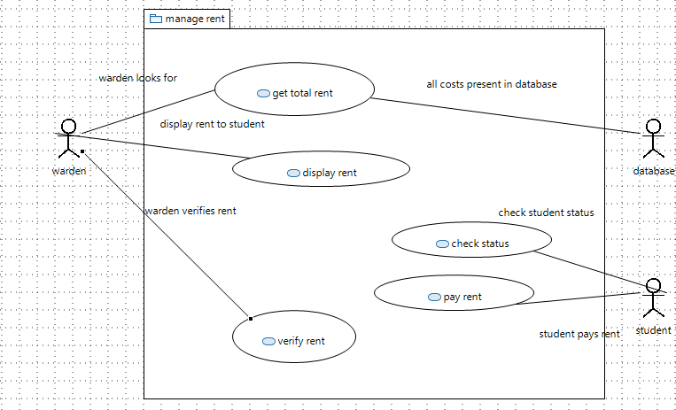***Manages student fees***

|  |  |
| --- | --- |
| Id | UC19 |
| USE CASE NAME | Get total rent |
| AUTHOR | FABIHA ATIQUE, MOHAMMAD USAMA |
| LAST REVISED | 26/11/2022 |
| DESCRIPTION | Warden checks the room’s rent plus the facility rent for each  student from the database. |
| PRIMARY ACTOR | Warden |
| SUPPORTING ACTOR | Student, database |
| PRECONDITION | The warden is connected to the internet.  The warden is logged in. |
| POSTCONDITION | The total amount is checked from the database. |
| MAIN SUCCESS SCENERIOS | 1. The warden checks the database. 2. The warden first sees the hostel’s rent for the student. 3. The warden then sees the rent of all the facilities the student is using. 4. The warden adds up the rent. |
| EXTENSIONS | *a. At any time, the system crashes.  2a. the warden reads incorrect rent from the database.  3a. the warden reads incorrect facility rent from the database. 4a. the rent is added incorrectly. |

|  |  |  |
| --- | --- | --- |
| Id | UC19 |  |
| USE CASE NAME | Display rent |
| AUTHOR | FABIHA ATIQUE, MOHAMMAD USAMA |
| LAST REVISED | 26/11/2022 |
| DESCRIPTION | The warden displays the total rent on screen. |
| PRIMARY ACTOR | Warden |
| SUPPORTING ACTOR | Database, student |
| PRECONDITION | The warden is registered in the system.  The warden is logged in.  The warden has calculated the total bill. |

|  |  |
| --- | --- |
| POSTCONDITION | The warden has printed the rent on the screen. |
| MAIN SUCCESS SCENERIOS | 1. The warden displays the rent calculated on the  screen. |
| EXTENSIONS | *a. At any time, the system crashes.  1a. the wrong rent is displayed on screen.  1a. no bill is displayed on screen. |

|  |  |
| --- | --- |
| Id | UC20 |
| USE CASE NAME | Check status |
| AUTHOR | FABIHA ATIQUE, MOHAMMAD  USAMA |
| LAST REVISED | 26/11/2022 |
| DESCRIPTION | The student will check his status to view his fee status. |
| PRIMARY ACTOR | Student |
| SUPPORTING ACTOR | Database, warden |
| PRECONDITION | The student is connected to the internet.  The student is logged in. |
| POSTCONDITION | The student is able to view his rent |
| MAIN SUCCESS SCENERIOS | 2. The student will view on the fee details. |
| EXTENSIONS | *a. At any time, the system crashes. |

|  |  |
| --- | --- |
| Id | UC21 |
| USE CASE NAME | Pay rent |
| AUTHOR | FABIHA ATIQUE, MOHAMMAD  USAMA |
| LAST REVISED | 26/11/2022 |
| DESCRIPTION | The student will pay the fees manually. |
| PRIMARY ACTOR | Student |
| SUPPORTING ACTOR | Database, warden |
| PRECONDITION | The student is connected to the internet.  The student is logged in.  The student has seen the rent he needs to pay/ |
| POSTCONDITION | The student pays the fees. |
| MAIN SUCCESS SCENERIOS | 1. The student pays the fees manually. |

|  |  |
| --- | --- |
| EXTENSIONS | *a. At any time, the system crashes.  1a. the student does not pay the fees.  1b. the student pays the wrong fee. |

|  |  |
| --- | --- |
| Id | UC22 |
| USE CASE NAME | Verify rent |
| AUTHOR | FABIHA ATIQUE, MOHAMMAD  USAMA |
| LAST REVISED | 26/11/2022 |
| DESCRIPTION | The warden will verify whether the student has paid the rent or  not |
| PRIMARY ACTOR | Warden |
| SUPPORTING ACTOR | Database, student |
| PRECONDITION | The warden is connected to the internet.  The warden is logged in  The student has paid the fees. |
| POSTCONDITION | The warden has updated the database |
| MAIN SUCCESS SCENERIOS | 1. The warden checks manually if the student has paid the fees or not 2. The warden updates the database. |
| EXTENSIONS | *a. At any time, the system crashes.  1a. the warden makes some mistake in checking.  2a. the fee is paid but warden forgets to update in the database. |

## Non-functional Requirements

##### Performance Requirements

The system requires concurrency to manage both the requests of the student and the warden. In the system.

##### Safety Requirements

As it’s a public hostel, the system requires us to ensure the safety of the users’ data in our database. There should be complete confidentiality and no data leaks are affordable.

##### Security Requirements

For any user to enter the system. Login credentials are needed to ensure the security of our users. We as developers need to ensure that the data is secure with us.

##### User Documentation

The user will be provided with a complete user guide to use and manage our system at the time of deployment.

# SDS

## System Architecture

The hostel management system is done by both maintaining the frontend and the backend. There are two users in our system, the student, and the warden, for both of these users we need to maintain the whole system.

### System Level Architecture

Deployment diagram

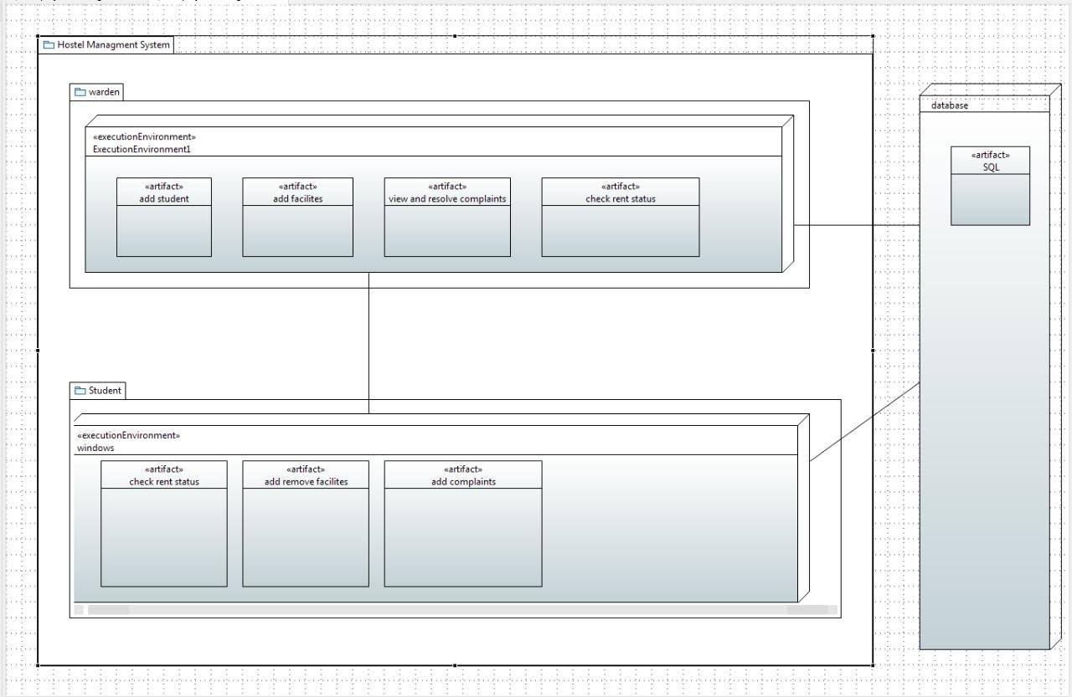

* 1. **Software Architecture**

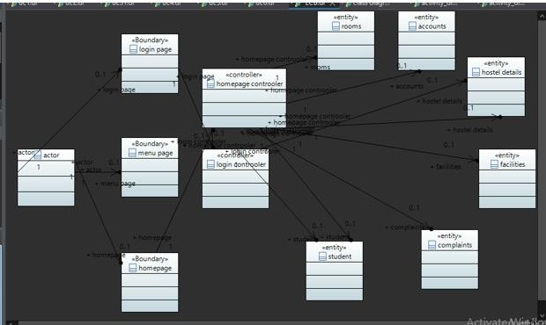

## Design Strategy

Beginning with the structure of the hostel management, the plan is to provide a portal for both the student and the warden to manage the hostel in a convenient way. To ensure that our system t

In our design phase, we have

## Detailed System Design

Class diagram

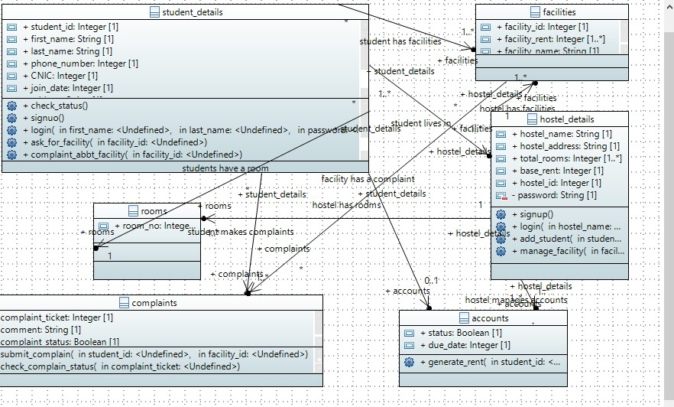

*ECB class diagram*

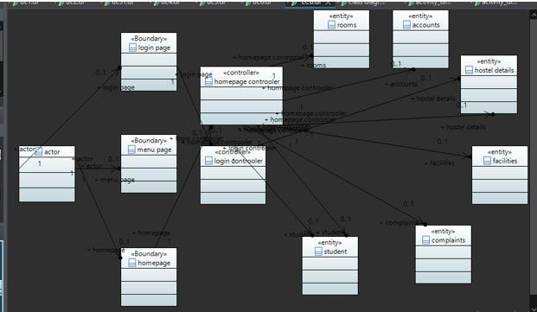

**public class** student_details {

/**

*

*/

**public** String first_name;

/**

*

*/

**public** String last_name;

/**

*

*/

**public int** phone_number;

/**

*

*/

**public int** CNIC;

/**

*

*/

**public** String guardian_name;

/**

*

*/

**public** String address;

/**

*

*/

**public int** join_date;

/**

*

*/

**private** String password;

/**

*

*/

**public int** student_id;

/**

*

*/

**public** hostel_details[] hostel_details;

/**

*

*/

**public** facilities[] facilities;

/**

*

*/

**public** complaints[] complaints;

/**

*

*/

**public** rooms rooms;

/**

*

*/

**public** accounts accounts;

/**

*

*/

**public void** signuo() {

}

/**

*

* **@param** first_name
* **@param** last_name
* **@param** password

*/

**public void** login(undef first_name, undef last_name, undef password) {

}

/**

*

*/

**public void** check_status() {

}

/**

*

* **@param** facility_id

*/

**public void** ask_for_facility(undef facility_id) {

}

/**

*

* **@param** facility_id

*/

**public void** complaint_abbt_facility(undef facility_id) {

}

/**

*

* **@param** facility_id

*/

**public void** withdraw_facility(undef facility_id) {

}

/**

*

*/

**public void** check_status() {

}

}

**public class** rooms {

}

/**

*

*/

**public int** room_no;

**public class** hostel_details {

/**

*

*/

**public int** hostel_id;

/**

*

*/

**public** String hostel_name;

/**

*

*/

**public** String hostel_address;

/**

*

*/

**public int**[] total_rooms;

/**

*

*/

**public int** base_rent;

/**

*

*/

**private** String password;

/**

*

*/

**public** facilities[] facilities;

/**

*

*/

**public** rooms[] rooms;

/**

*

*/

**public** accounts[] accounts;

/**

*

*/

**public void** signup() {

}

/**

*

* **@param** hostel_name
* **@param** password

*/

**public void** login(undef hostel_name, undef password) {

}

/**

*

* **@param** student_id

*/

**public void** add_student(undef student_id) {

}

/**

*

* **@param** facility_id

*/

**public void** manage_facility(undef facility_id) {

}

}

**public class** facilities {

}

**public class** complaints {

/**

*

/**

*

*/

**public int** facility_id;

/**

*

*/

**public** String facility_name;

/**

*

*/

**public int**[] facility_rent;

/**

*

*/

**public** complaints[] complaints;

/**

*

*/

**public int** complaint_ticket;

/**

*

*/

**public** String comment;

/**

*

*/

**public boolean** complaint_status;

* **@param** student_id
* **@param** facility_id

*/

**public void** submit_complain(undef student_id, undef facility_id) {

}

/**

*

* **@param** complaint_ticket

*/

**public void** check_complain_status(undef complaint_ticket) {

}

}

**public class** accounts {

/**

*

/**

*

*/

**public int** due_date;

/**

*

*/

**public boolean** status;

* **@param** student_id

*/

**public void** generate_rent(undef student_id) {

}

}

### 8.1. Database Design

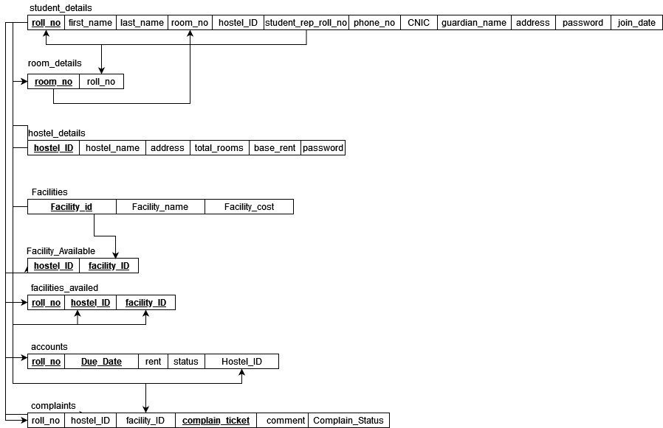

#### ER Diagram

* + 1. ***Data Dictionary***

[The convention recommended for writing the data dictionary is as follows.]

* + - 1. ***Data 1***

Student

The student logs in and does multiple jobs like managing the facilities he is using and see his rent and amount he has to pay.

***8.1.2.2. Data 2***

Hostel details

The hostel details are managed by the warden; the warden manages the facilities for the whole hostel

and checks the rent status for each student and the issue them the fee challan so that the student can pay the fee.

* + - 1. ***data 3***

rooms

the rooms are the essential data is to be present in any hostel. The room can be issued by the warden to a student.

* + - 1. ***data 4***

Facilities

The facilities are managed by the students as well as the warden. The student will manage for himself only while the warden will be managing for the whole hostel

* + - 1. **data 5**

Accounts

Accounts data is important to keep track of what charges are due on each student. Since each student is paying different fees because they are availing different facilities. It is also important to know which student has paid the fees and which has not.

###### data 6

Complaints

Complaints data is important to keep, the complaints regarding the facilities are stored and managed there.

###### data 7

Facility_available

The facilities available are stored in a table so that the warden knows which facilities are allowed by the admin.

###### data 8

Facility _availed

The facilities which are available by a hostel are kept in a separate table.

|  |  |  |  |  |  |  |  |
| --- | --- | --- | --- | --- | --- | --- | --- |
| **< Data 1>** | | | | | | | |
| ***Name*** | | *Student* | | | | | |
| ***Alias*** | | *Not applicable* | | | | | |
| ***Where-used/how- used*** | | *The student is an entity class. The student data will be provided by the student and inserted in the database by the admin after verified by the warden.* | | | | | |
| ***Content description*** | | *The student data is to maintain the records of each student living in our hostel.* | | | | | |
|  | | | | | | | |
| ***Column Name*** | ***Description*** | | ***Type*** | ***Length*** | ***Null able*** | ***Default Value*** | ***Key Type*** |
| *Roll_no* | *The unique ID assigned to each student* | | *Intege r* | *Standard* | *No ]* | *1 greater than the roll_no of previous student* | *PK* |
| *First_nam e* | *The first name of the student* | | *String* | *20*  *characters* | *No* | *Abc* | *None* |
| Last_name | The last name of  the student | | String | 20 characters | No | Abc | None |
| Room_no | The room number assigned to the  student | | Integer | 2 digits | No | None | FK |
| Hostel_ID | The hostel ID of  the hostel | | Integer | 2 digits | No | 1 greater than the previous  hostel’s Id | FK |
| Phonr_no | The phone number  of the student | | Long int | Standard | No | None | None |
| CNIC | The student cnic  number | | Integer | standard | No | None | Unique |
| Guardian_name | The name of the  guardian of the student | | String | 20 characters | No | Abc | None |
| Address | The home address  of the student | | String | 20 characters | No | None | None |
| Password | The password of  the student | | String | standard | No | None | None |
| Voin date | The date on which  the student joined | | Date | Standard | No | none | None |

|  |  |
| --- | --- |
| **< Data 2>** | |
| ***Name*** | *Hostel_details* |
| ***Alias*** | *Not applicable* |
| ***Where-used/how- used*** | *The hostel details is an entity class, it will hold the information related to the hostel, it will be managed by the warden* |
| ***Content description*** | *The hostel_details will hold all the details related to the hostel.* |

|  |  |  |  |  |  |  |
| --- | --- | --- | --- | --- | --- | --- |
|  | | | | | | |
| ***Column Name*** | ***Description*** | ***Type*** | ***Length*** | ***Null able*** | ***Default Value*** | ***Key Type*** |
| *Hostel_ID* | *The unique ID assigned to each hostel* | *Intege r* | *Standard* | *No* | *1 greater than the Id assigned to the previous hostel* | *PK* |
| *Hostel_na me* | *The name of the hostel* | *String* | *20*  *characters* | *No* | *Abc* | *None* |
| Address | The address of the  hostel | String | 20 characters | No | None | None |
| Total_rooms | The number of rooms in a hostel | Integer | 2 digits | No | None | None |
| Base_rent | The rent of the  hostel | Integer | Standard | No | None | None |
| Password | The password of the warden to enter  in the system | String | Standard | No | None | None |

|  |  |
| --- | --- |
| **< Data 3>** | |
| ***Name*** | *Rooms* |
| ***Alias*** | *Not applicable* |

|  |  |
| --- | --- |
| ***Where-used/how- used*** | *The rooms are an entity class in our system. It contains all the information about the rooms in the hostel* |
| ***Content description*** | *The rooms are specific to each hostel,, these are managed by the warden and the admin.* |

|  |  |  |  |  |  |  |
| --- | --- | --- | --- | --- | --- | --- |
|  | | | | | | |
| ***Column Name*** | ***Description*** | ***Type*** | ***Length*** | ***Null able*** | ***Default Value*** | ***Key Type*** |
| *Room_no* | *The room number assigned to every room* | *Intege r* | *Standard* | *No* | *1 greater than the Id assigned to the previous room* | *PK* |
| *Roll_no* | *The student roll number* | *intege r* | *Standard* | *No* | *None* | *FK* |

|  |  |
| --- | --- |
| **< Data 4>** | |
| ***Name*** | *Facilities* |
| ***Alias*** | *Not applicable* |
| ***Where-used/how- used*** | *The facilities are the entity class in our system, these classes are maintained by the student and the warden.* |
| ***Content description*** | *The facilities table consists of the number of facilities and their names* |

|  |  |  |  |  |  |  |
| --- | --- | --- | --- | --- | --- | --- |
|  | | | | | | |
| ***Column Name*** | ***Description*** | ***Type*** | ***Length*** | ***Null able*** | ***Default Value*** | ***Key Type*** |
| *Facility_I D* | *The unique id assigned to each facility* | *Intege r* | *Standard* | *No* | *1 greater than the previous facility in the table* | *PK* |
| *Facility_n ame* | *The name of the facility* | *String* | *Standard* | *No* | *None* | *PK* |
| *Cost* | *The cost of that facility* | *integer* | *standard* | *No* | *None* | *None* |

|  |  |
| --- | --- |
| **< Data 5>** | |
| ***Name*** | *Accounts* |
| ***Alias*** | *Not applicable* |
| ***Where-used/how- used*** | *The accounts table is used to save the accounts details and rent related information of the students.* |
| ***Content description*** | *The entity contains the rent details of the students* |

|  |  |  |  |  |  |  |
| --- | --- | --- | --- | --- | --- | --- |
|  | | | | | | |
| ***Column Name*** | ***Description*** | ***Type*** | ***Length*** | ***Null able*** | ***Default Value*** | ***Key Type*** |
| *Roll_no* | *The toll number of a student* | *Intege r* | *Standard* | *No* | *NONE* | *FK, PK* |
| *Hostel_id* | *The hostel id* | *integer* | *Standard* | *No* | *None* | *FK* |
| *Due_date* | *The date when the rent is due* | *Date* | *standard* | *No* | *None* | *None* |
| *Rent* | *The amount of rent to be paid* | *Integer* | *Standard* | *no* | *None* | *None* |
| *status* | *The status of the rent being paid or not* | *Boolea n* | *Standard* | *no* | *None* | *None* |

|  |  |  |  |  |  |  |  |
| --- | --- | --- | --- | --- | --- | --- | --- |
|  | | | | | | | |
| **< Data 6>** | | | | | | | |
| ***Name*** | | *Complaints* | | | | | |
| ***Alias*** | | *Not applicable* | | | | | |
| ***Where-used/how- used*** | | *The entity class complaints is there to maintain the records of all the complaints regarding a facility. These complaints are registered by the students* | | | | | |
| ***Content description*** | | *All the details regarding complaints are stored there* | | | | | |
| ***Column Name*** | ***Description*** | | ***Type*** | ***Length*** | ***Null able*** | ***Default Value*** | ***Key Type*** |
| *Roll_no* | *The toll number of a student* | | *Intege r* | *Standard* | *No* | *NONE* | *FK* |
| *Hostel_id* | *The hostel id* | | *integer* | *Standard* | *No* | *None* | *FK* |
| *Facility_id* | *The id of the facility the student is using* | | *Integer* | *standard* | *No* | *None* | *FK* |
| *Complain*  *_ticket* | *The id of the complain* | | *Integer* | *Standard* | *no* | *None* | *PK* |
| *Comment* | *The comment left by the student for the facility* | | *String* | *Standard* | *no* | *None* | *None* |

|  |  |  |  |  |  |  |
| --- | --- | --- | --- | --- | --- | --- |
| *Status* | *The status of the complaint being registered* | *Boolea n* | *Standard* | *No* | *None* | *None* |

|  |  |  |  |  |  |  |  |
| --- | --- | --- | --- | --- | --- | --- | --- |
|  | | | | | | | |
| **< Data 7>** | | | | | | | |
| ***Name*** | | *Facilities_available* | | | | | |
| ***Alias*** | | *Not applicable* | | | | | |
| ***Where-used/how- used*** | | *This class is used by the warden to know what facilities are available in the list, only these facilities can be added in a hostel.* | | | | | |
| ***Content description*** | | *All the details related to a facility is present in the tale.* | | | | | |
| ***Column Name*** | ***Description*** | | ***Type*** | ***Length*** | ***Null able*** | ***Default Value*** | ***Key Type*** |
| *Hostel_id* | *The id of the hostel which is using the facility* | | *Intege r* | *Standard* | *No* | *NONE* | *FK. PK* |
| *Facility_id* | *The Id of the facility.* | | *integer* | *Standard* | *No* | *None* | *FK*  *,PK* |

|  |  |  |  |  |  |  |  |  |
| --- | --- | --- | --- | --- | --- | --- | --- | --- |
|  |  | | | | | | | |
| **< Data 8>** | | | | | | | |
| ***Name*** | | | *Facilities_avaied* | | | | |
| ***Alias*** | | | *Not applicable* | | | | |
| ***Where-used/how- used*** | | | *This class is used to view what facilities are availed by the hostel.* | | | | |
| ***Content description*** | | | *All the details related to a facility is present in the tale.* | | | | |
| ***Column Name*** | | ***Description*** | ***Type*** | | ***Length*** | ***Null able*** | ***Default Value*** | ***Key Type*** |
| *Roll_no* | | *The toll number of a student* | *Intege r* | | *Standard* | *No* | *NONE* | *FK,PK* |
| *Hostel_id* | | *The hostel id* | *integer* | | *Standard* | *No* | *None* | *FK, PK* |
| *Facility_id* | | *The id of the facility the student is using* | *Integer* | | *standard* | *No* | *None* | *FK,PK* |

### Application Design

The application was designed in the following stages.

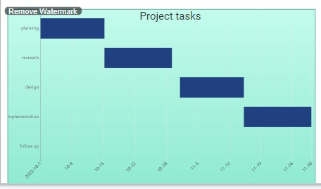

#### Sequence Diagram

* + - 1. ***<Sequence Diagram 1>***

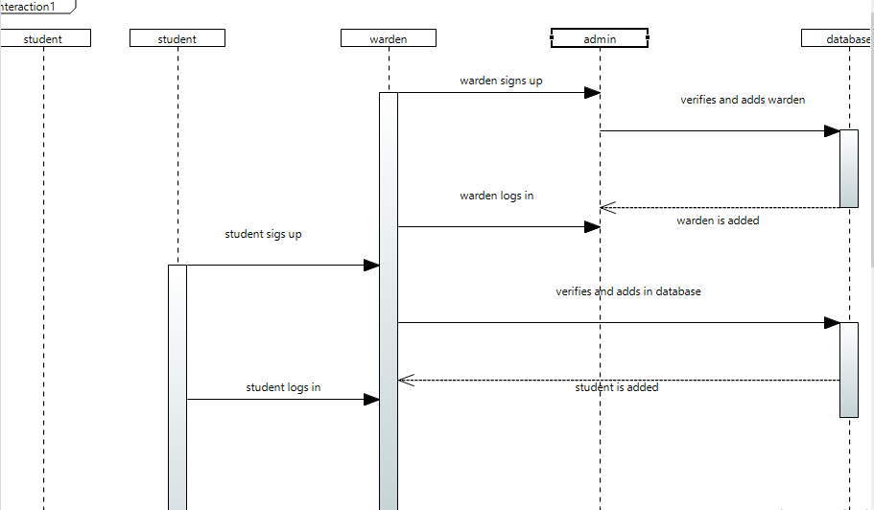

* + - 1. ***<Sequence Diagram 2>***

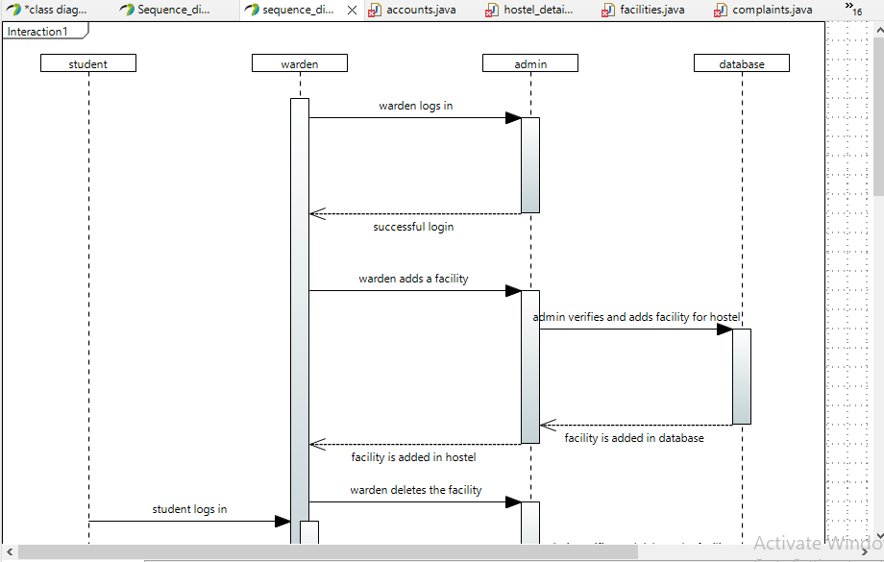

.

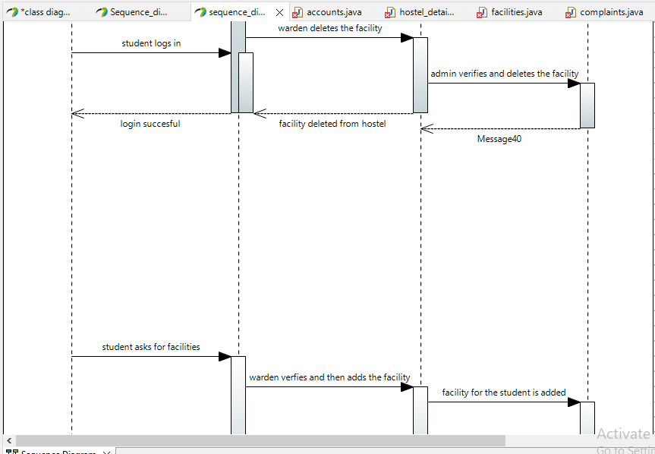

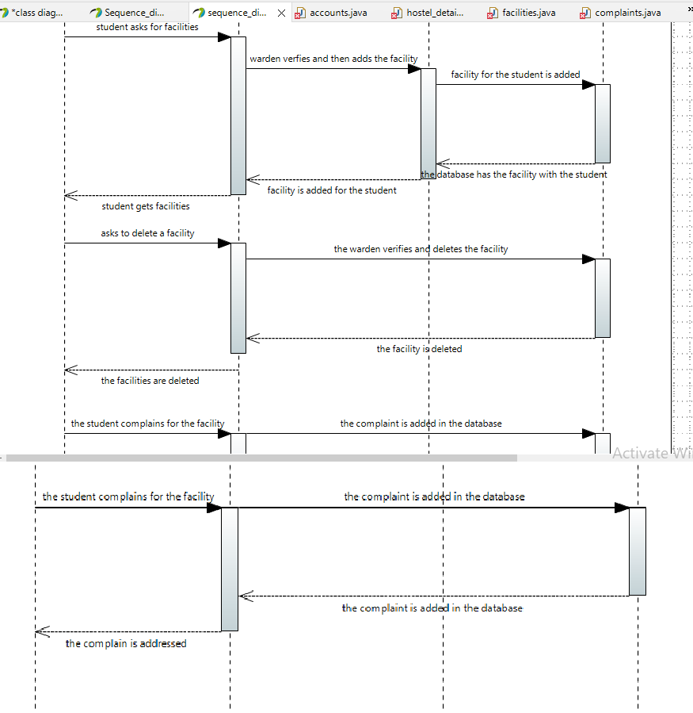

* + - 1. ***<Sequence Diagram n>***

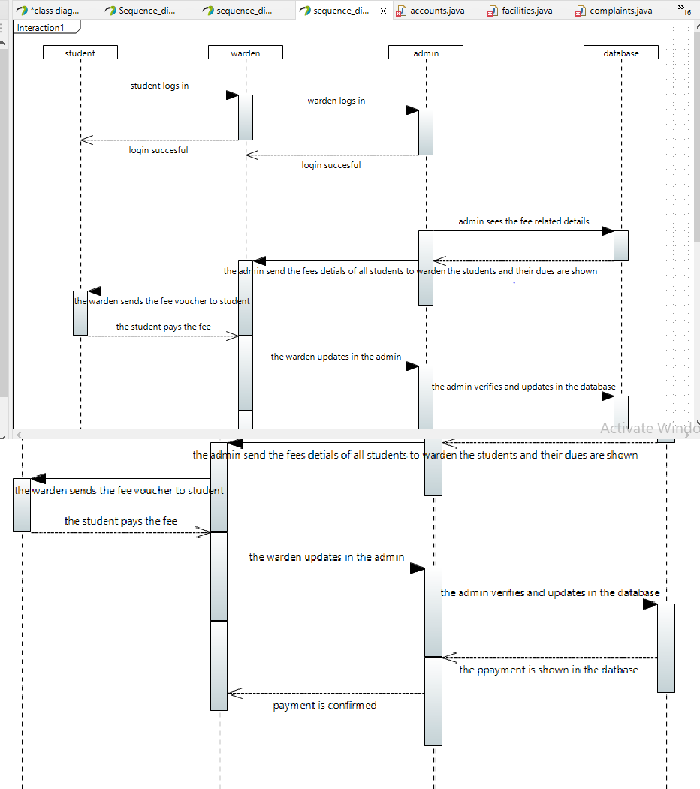

#### State Diagrams

* + 1. ***<state diagram 1>***

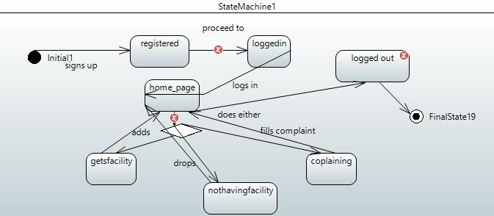

.

.

* + - 1. ***<State Diagram 2>***

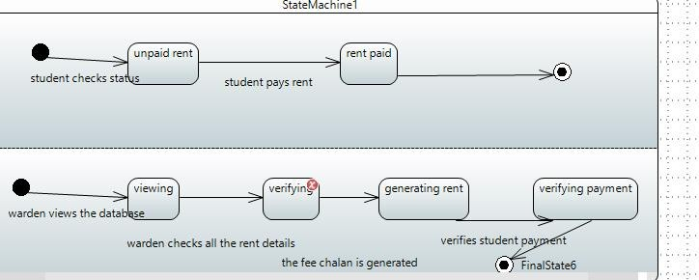

* + - 1. ***<State diagram 3>***

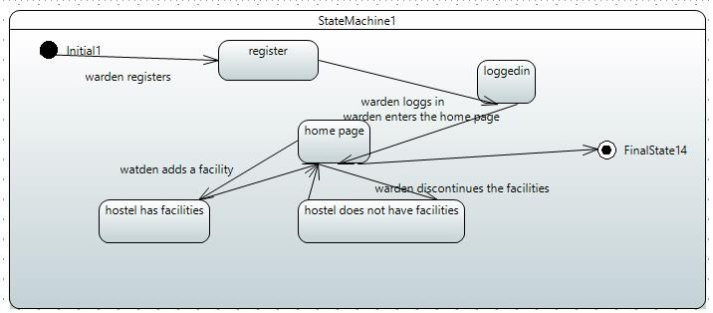

#### Activity Diagram

* + - 1. ***<Activity Diagram 1>***

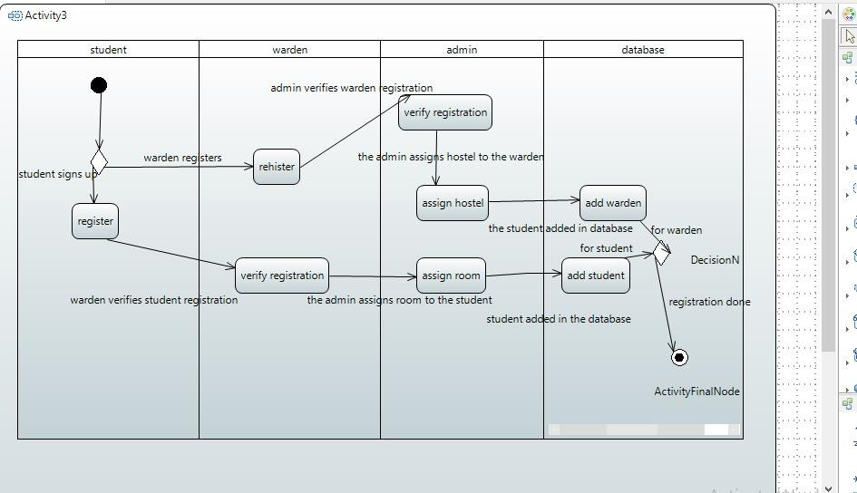

* + - 1. ***<Activity Diagram 2>***

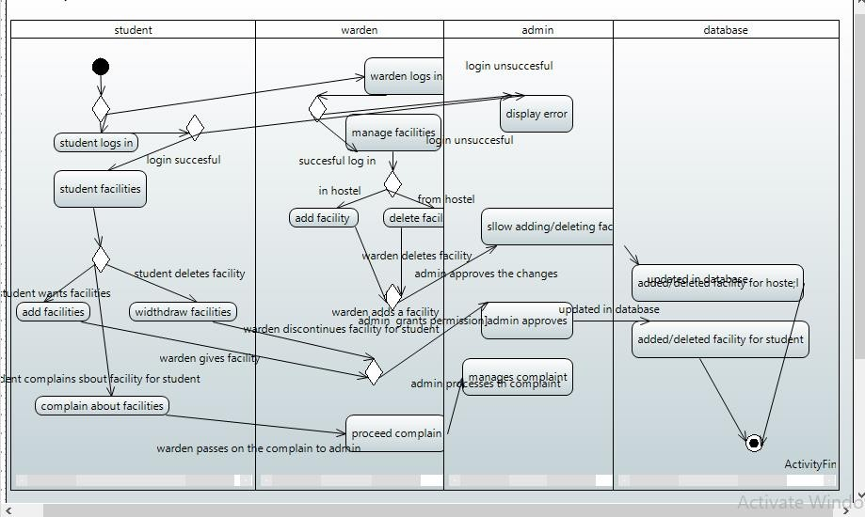

* + - 1. ***Activity Diagram 3>***

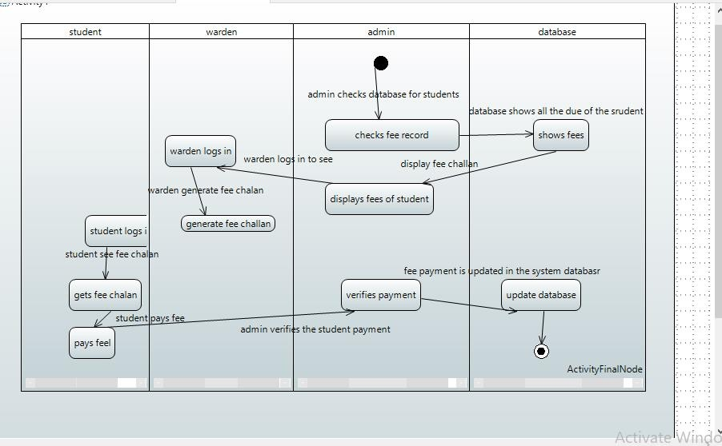

#### References

No references taken specifically, just used a few YouTube video tutorials to understand a few things.

#### Appendices

Not applicable